RESUME

MADIREDDY SHASHANTH REDDY

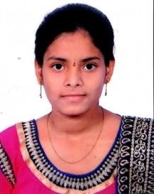 Email id: shashanthreddy01@gmail.com

Mobile: 7659999886

# Objective:

* To enhance my professional skills, capabilities and knowledge in an organization which recognizes the value of hard work and trusts me with responsibilities and challenges.

# Education:

|  |  |  |  |
| --- | --- | --- | --- |
| **C**ourse | Institution | Year of passing | Percentage/cgpa |
| B. Tech(CSO)  ( pursing) | Ace engineering  college | 2025 | 7.2 |
| Board of intermediate | Toppers junior college | 2021 | 73 |
| Secondary School  (SSC) | St.Anthony Grammar high school | 2019 | 9.2 |

**Skills:**

* Personal skills : Adaptability, Hard Working.
* Programming skills : Java, C, Python.
* Operating Systems : Windows, linux.
* Database : Mysql.

# 

# Certifications:

* I have completed a **Salesforce** certification and got certified

**Personal Details:**

Name : Madireddy Shashanth Reddy

D.O.B : 19/12/2002

Father’name : M Malla Redy

Gender : Male Language known : English, Telugu

Address : Dammaiguda,Hyderabad opp old bus stopnear water tank

Hno- 2-79

# Declaration:

* I hereby declare that the information mentioned above are correct to best of my knowledge and belief

M.Shashanth reddy